Exercise 6 Put the words in the correct order to make sentences.
a) My sister – a banana - has
………………………………………………………………………
b) I – have – don’t – a sandwich
………………………………………………………………………
c) She – a biscuit – has
………………………………………………………………………
d) drinks – My brother – has
………………………………………………………………………
e) What – you – do – have ?
………………………………………………………………………
f) I – grapes – don’t – have
………………………………………………………………………
g) She – have – doesn’t – a lunchbox
………………………………………………………………………
h) Do – have – a pear – you ?
………………………………………………………………………
i) Tony – two – sandwiches – has
………………………………………………………………………
j) What – she – have – does ?
………………………………………………………………………
k) Does – an orange – he – have ?
………………………………………………………………………
l) My mom – doesn’t – a pineapple – have
………………………………………………………………………
m) I – biscuits – don’t – have
………………………………………………………………………
Exercise 6 Read and Tick ( √ ) or cross ( X )
Hello. I’m Rose. and I’m a student . This is my lunchbox. Let’s look inside. I have a hamburger , an apple and a drink . I don’t have a banana today, but it’s a very nice lunch! | 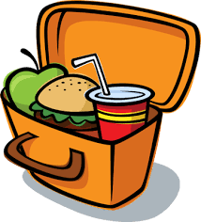

- Her name is Sally.
- She has a hamburger in her lunch box.
- She doesn’t have an apple in her lunch box.
- She has a drink in her lunch box.
- She has a banana and an orange in her lunch box.
Exercise 7 Look and write : I have or I don’t have
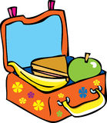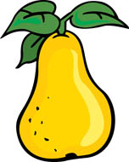

1.I have a lunchbox. 2…………………………………………
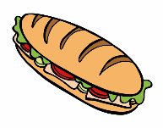

3. ………………………………………… 4…………………………………………

Exercise 7 Read , look and write :
an | a

 | 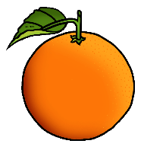
…………apple | …………orange | …………pear
 | 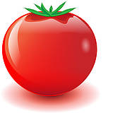 | 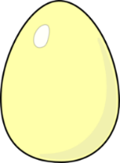
………… banana | ………… tomato | ………… egg
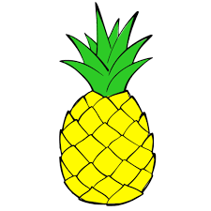 |  | 
………… pineapple | ………… umbrella | …………ice cream
Exercise 8 Circle the odd one out
- living room | - kitchen | - bedroom | - dress
- T- shirt | - trousers | - socks | - house
- grapes | - books | - pineapple | - pears
- mom | - dad | - grandpa | - friend
- pen | - ruler | - yellow | - rubber
- ten | - green | - pink | - purple
- hat | - coat | - shoes | - biscuit

